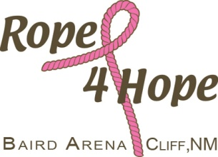

7th Annual Rope 4 Hope Team Roping
November 1st 2015

Enter at 0900 Rope at 1000

Entries taken on site; we appreciate pre-entries!

Name ___________________________________________Phone _______________

Classification # ________ Head or Heel

Partners name(s)_______________________________________________________

Draw all three in Pick/Draw? Yes or No

 |  |  |  | Fee’s
#13 | Pick 1/Draw | $100/man | Enter 1X | $
#11 | Pick 1/Draw | $100/man | Enter 1X | $
All Girls | Pick1/Draw | $60/girl | Enter 1X | $
#9 | Pick 1/Draw | $100/man | Enter 1X | $
Parent/child | Pick 1/Draw | $50/person | Enter 1X | $
 |  |  | Total Fee’s | $

Buckles to Champion Header and Heeler in the numbered ropings.

Make checks payable to: Mail to:
Rope 4 Hope Rope 4 Hope
PO Box 302
Cliff NM 88028

Best dressed guy in pink will be recognized.

Dummy Roping for youth 10 and under after the #13.

Men’s Barrel Race on Saturday, the 30th for men who are “Tough Enough”to race (use your wife’s/daughters/girlfriends horse) following the Open 4D and Youth Divisions. Entry fee $20 including ground fee. Check and Tiara awarded to winning guy.

