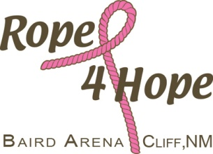

7th Annual Rope 4 Hope Barrel Race
October 31st

Exhibitions at 1000 Arena grooming at 12:30 Race at 1:30

Entries taken on site, but we really appreciate pre-entries.

Name ___________________________________________Phone _______________
Email address * _______________________________________________________
Horse(s) name _________________________________________________________

 |  |  | Number of entries | Fee’s
Time only’s | $5, or 3 for $10 |  |  | $
Open 4 D | $55 |  |  | $
Youth Open | $35 |  |  | $
Men’s Race | $25 |  |  | $
Carry over | $55 |  |  | $
 | No ground fee |  | Total Fee’s | $

Buckles in each Division, and to Youth with fastest time.
75% payback. Slits are ½, ½, and 1 second.

Make checks payable to: Mail to:
Rope 4 Hope Rope 4 Hope
PO Box 302
Cliff NM 88028

Pink Queen award to best and most Pink on Horse and Rider.

Manly Barrel Race for men who are “Tough Enough”to race (use your wife’s/daughters/girlfriends horse) following the Open 4D and Youth Divisions. Check and Tiara awarded to winning guy. Other awards may apply.

***Release to Race I voluntarily agree to waive any and all rights by myself or any representative to sue and hereby release the Event Sponsor and Arena owner from liability, loss, claims, or actions for injury, death, expenses , or damage to person or property resulting from the inherent risks of th e Event or resulting from any action or inaction by the Event sponsor and/or Arena owner.
Signed_________________________________________Date________________

